History of the E. V. Gray Purple Motor
In 1957 E.V. Gray and Marvin Cole suddenly started drawing detailed plans for a new kind of electric motor in Mr. Gray’s living room. This is the first observed account of the geneses of this technology as recounted by Mr. Gray’s 7 year old 2nd son Dr. James Gray.
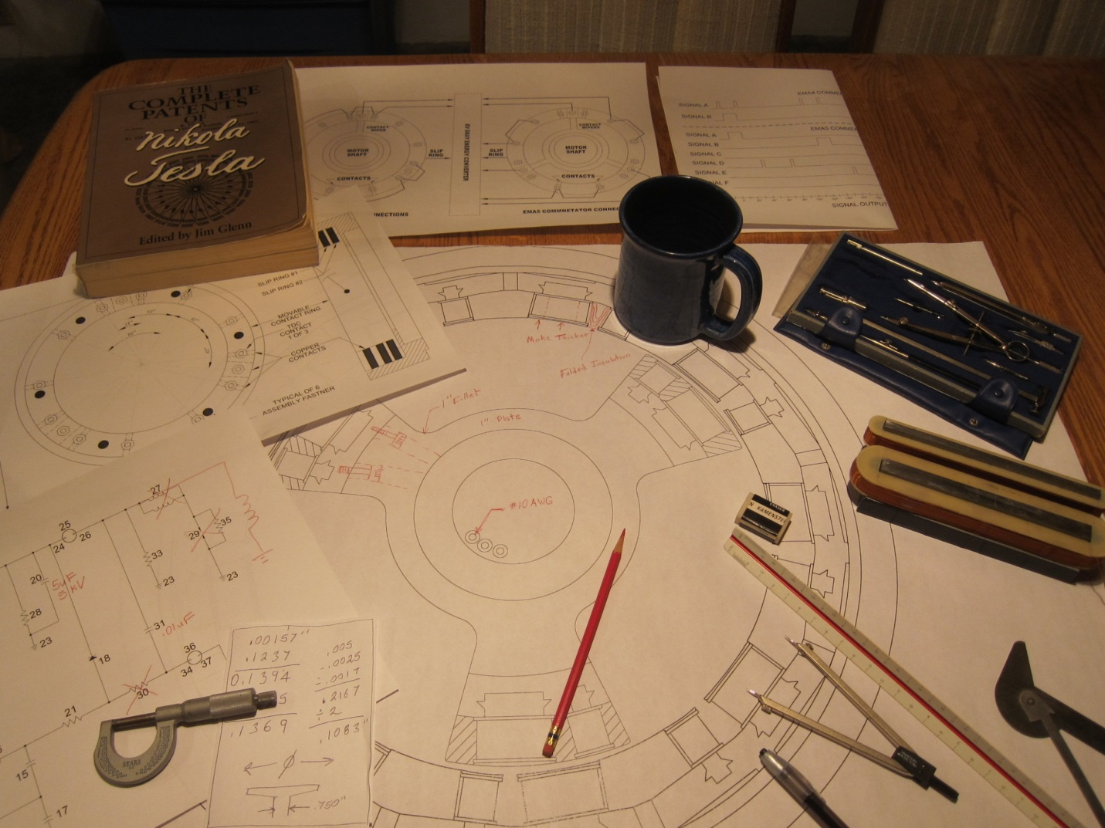
Actually, there’s more to the early story than this sudden burst of inspiration implies. It is speculated that the whole Free Energy Engine technology didn’t start as a motor at all. It started as a humble toy that used electromagnets to hurl projectiles high into the air. It was battery powered device that used some kind of auto ignition coil circuit to charge a storage capacitor. It would take about 30 seconds to charge the capacitor prior to each firing.
Years later Gray admitted to his lawyer that the original information came for a Russian immigrant named André Poppoff. Mr. Poppoff claimed, according to Gray, to have been associated with Dr. Tesla prior to his death in 1943. Gray didn’t disclose exactly what kind of equipment and/or plans he had received. The speculated assumption is that it was some kind of popping coil apparatus.
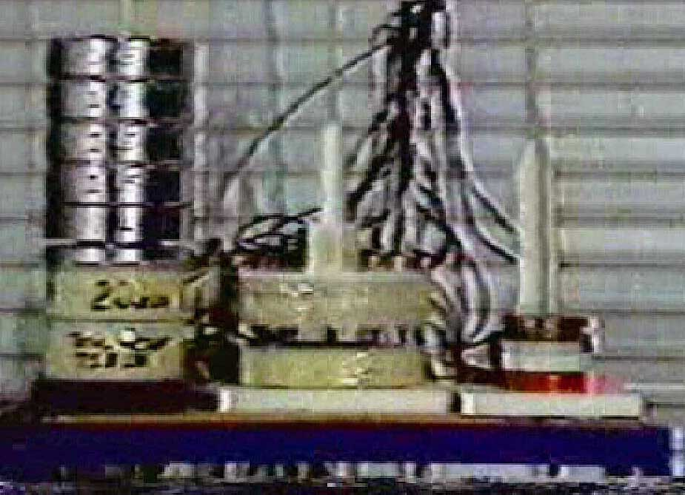
Mr. Gray’s friend Marvin Cole took a special interest in this novelty and must have done some basic experiments with it. Adding additional weight to the projectile would have been a natural early step. It is assumed that Mr. Cole quickly discovered that this device could lift some pretty heavy loads. Since Mr. Cole had a MS in mechanical engineering he probably knew how to convert the total energy of the projectile (travel height X weight X conversion factor) to the energy stored in the capacitor. To his utter amazement he noticed that the projectile displayed having way more energy that what could have been stored in the capacitor. After a few more weeks of additional detailed experiments it became clear that this toy circuit had the ability to produce more energy that it consumed. In order for Mr. Cole to see these kinds of results, with the simple equipment described, the effective Coefficient of Performance was probably on the order of 5.0. It became obvious that if this energy could be harvested then both men could become rich beyond their wildest dreams.
The development concepts of a motor like device that could transform the linear action into a rotary motion hit the living room table in earnest. The excess energy only seemed to be available for a brief moment of time and therefore a pulse repulsion type of motor was conceived. However, there was a lot about the physics of this new process that neither man knew. It was going to take a bundle of $$$ to get those answers and engineer a marketable rotary converter.
The fortunate feature of this kind of Free Energy is that its performance can be easily and accurately measured with a Volt meter, a scale, and a measuring tape. In the LA area at the time there were several independent thinking people with lots of money and an understanding of technology. A few of these successful Mavericks’ might just risk a far out investment if it could be shown to them that it indeed worked in principle. The demonstration of a few heavily weighted popping coil devices and set of converter motor plans probably made for a pretty good venture capital presentation.
It didn’t take long to convince a few individuals that this plan was something BIG. Two very successful geologists from the oil industry came forward willing to fund a long term meaningful research program. They were more interested in giving the Free Energy to the under privileged people of the world. Thus, they were not in a huge rush to make billions. The grand kick off of this OU Technology began in the early 60’s. Obviously, secrecy was of the upmost importance if the full market potential of this Free Energy technology was to be achieved. The now funded project went underground and even the members of E.V. Gray’s family had no idea as to what was happening.
In 1960 Gray had to leave town for personal financial reasons (Probably gambling debts) and was gone for 5 years. Mr. Cole continued on with the research, but kept Mr. Gray informed of its progress. In 1964 it is assumed that Mr. Cole sent Gray a prototype power supply while he was living in Las Vegas. Gray experimented with this apparatus but eventually destroyed it in an explosion. (No one was hurt).
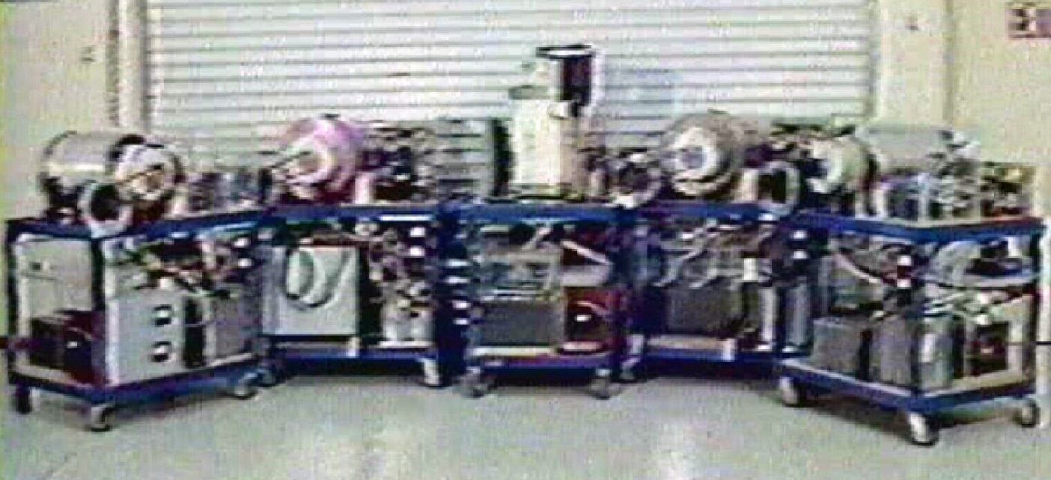
A Family photo of five of the 3-Pole E-Motors taken from the 1986 Zetech promotion video. These motors were all modified in 1980 to run on 5KV DC derived from 240 VAC 100 Amp mains. Despite the internal rewinding of the electromagnets and the removal of vacuum tube switching it is thought that the carts that these motors are mounted on are largely the same as they were when constructed circa 1961 to 1965. From left to right, the E4 -“Black Motor”, the E2 - “Purple Motor”, the E5 - “White Motor”, the E1 -“Gold Motor”, and the suspected E0 Motor (no color nick name).
The Five Cole Pulse Motors were probably built between 1960 and 1965 with E.V. Gray not in attendance most of the time. These machines are called pulse motors because they are constructed much differently that the later, and more advanced, Free Energy Engines. However it is assumed that the researchers (or at least the most inner circle members) knew full well that they were working with some kind of Over Unity process from the very beginning.
Each motor case and its major components are stamped with a number 1 thru 5. The motors were later nicked named according to their predominate color. Each motor appears to have been designed to explore some aspect of the novel energy being studied. Many of the support components like the control commutator, mounting brackets, power supply components, batteries, and load generators are interchangeable. Even though the machining of these devices seems less than precision by today’s standards no one doubts that a lot of money was involved in their construction.
Each motor was constructed on its own wheeled steel frame support cart. They were all meant to be experimental test stations and were thus built to allow for several kinds of wiring configurations. The “Purple” motor appears to have been built to explore one means to harvest additional anomalous energy that seemed to develop around the motor electromagnets during the explosive repulsion event. It is speculated that the discovery of this additional energy lead to the next stage of refinement that started the era of the true Free Energy Engines.
In 1971 or so, Marvin Cole abruptly left the project. He made Mr. Gray believe that he was not coming back. Mr. Gray, for whatever reasons, then claimed the entire development to date as his own. He then made arrangements to eliminate all of the original investors and researchers. During this business transition Gray took all of the experimental equipment into hidden storage. No doubt Mr. Cole was blamed for confiscating the technology. Theses motors stayed in storage until 1980.
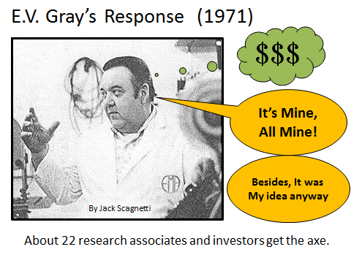
Unfortunately, when all of these early prototypes were taken out of storage they were “Retro-Fitted” by Gray’s hired assistants in 1980. These technicians were not informed that they were working with a Free Energy technology. Mr. Gray’s vague instructions went something like, “fix these machines for me”. (For $200 a week) Doing the best they could to make sense of the strange equipment in front of them they had the motor coils re-wound, removed all the vacuum tube control circuits, rewired the control commutator, and eliminated excess components that they didn’t understand. Now the motors would now start from a standstill and could reverse direction as well. However, these surface improvements came at a huge cost. Now, it took 10 KVA of power to turn the motor at about 500 rpm with no attached load. All of the Free Energy technology had been gutted from the “Purple” motor. It is questionable that Mr. Gray knew what was happening, or perhaps he had his own agenda to sell this age-changing technology without his assistants demanding a piece of the action.
After Gray’s death in 1989 a Mr. Russell Audrey of Dodge City Kansas took delivery of a large number of these early Pulse motors, including the “Purple Motor”. He then organized yet another research effort to recover this lost Free Energy Technology. After two years and several hundred thousand dollars, he gave up. The surviving equipment went into storage. Shortly after Mr. Audrey’s death in 2006 his family made arrangements to dispose of this novel equipment that had cut deeply into their inheritance. Mr. John Riley of California was contracted to 1) reverse engineer this equipment if possible and 2) sell it to the highest bidder if its secrets could not be discovered.

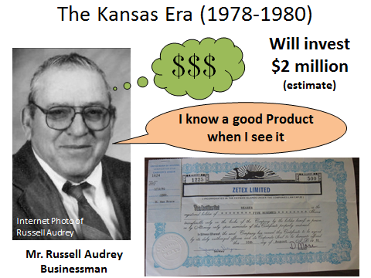
Mr. Brooks Agnew, an outside technical specialist from North Carolina, was contracted in Aug. of 2007 to examine the “Purple” and “Gold” Motors. Additional evaluations by other specialists could have been done as well. By 2009 Mr. Riley was making quite inquires to respected members of the Free Energy Community to assess the value of his consigned assets. Apparently the overall demand didn’t seem lucrative enough so in June of 2010 Mr. Riley offered the “Gold” (The E-1) Motor for public bid by means of a YouTube slide show (Quite good).
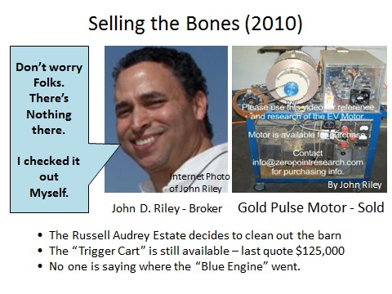
Mr. Reginald Garcia and his partner Joe purchased the “Purple” Motor in early 2012 from John Riley. Their hope is to again reverse engineer this age-changing technology from the surviving remains of this early 60’s Pulse Motor. This is indeed a formidable challenge given the history outlined above. However, the rewards are well worth the serious time investment for a team or individual who is/are given the resources to devote a full time effort into the solution.
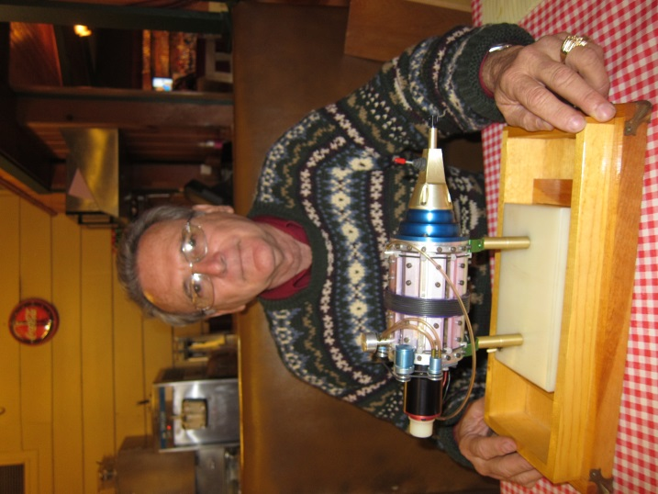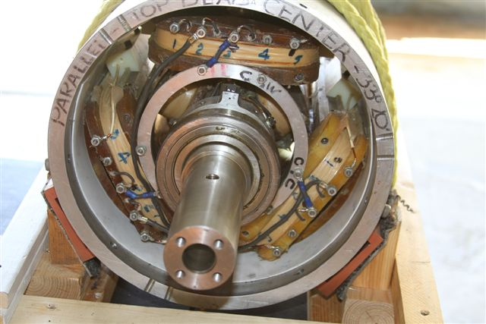

What Survived?
The components that are thought to be original are:
The major parts of the Motor (Case, shaft, electromagnet cores, bearings, mountings, end caps)
The major parts of the commutator controller and the power slip rings
The six Ignitrons and their associated bus bars and heat sinks
The three Ignitron Pulse Transformers
The Delco Remy 12 volt DC generator and its mounting equipment
The Ohmite high current rotary switch
The steel frame cart

What was removed?
The internal electromagnets were rewired in 1980 with #14 AWG magnet wire to increase current flow. The original windings were reported to be wound from a much smaller gauge wire, about #24 AWG or so. The original electromagnets were multi-winding devices and not simple solenoids like they are today.
The Ignitrons were originally controlled with vacuum tube Thyratrons and smaller triodes. These and all of their associated support components were removed in 1980.
The Ohmite rotary switch was originally wired so that a number of 1.5 volt taps could be selected from one of the battery arrays. This would provide a voltage selection from 1.5 to 12 volts in five steps. Today the Ohmite switch serves as a simple high current on-off switch.
Certain devices that looked like high voltage storage capacitors, but in fact may have been something else. Like a pulse forming network, low pass filter, delay line, or a combination of these.
What was added?
All of the colored high current jacks used for external connections.
The blue plastic “Timing Box” with its NE555 circuit, Relay, switches, transistor, and support components
The collection of high current relays that control the I/O of the 12 volt power distribution
The two 1,500 Volt Zener Diode voltage limiter cards (5000 Volts DC in 1500 Volts DC out at a low current)
The huge power diode and its fan
Six New storage capacitors

How the Purple Motor works in its present condition
According to Brooks Agnew, he was able to drive the motor (no load) with the on board DC generator (running in motor mode) for about 15 minutes on a fully charged new 12 volt battery.
Nelson Schlaft claims that the onboard batteries would “Hardly run the motor at all” It is unclear if he meant that was using the same method that Mr. Agnew used or if that was operating in the High Voltage Mode using a (now missing) 12-5kV DC to DC inverter?
When the “Purple” motor was retro-fitted in 1980 it was intended to be powered from a remote 5 kV 50KVA power supply (Called the “Trigger Cart”). The 5 kV was delivered by means of cables to the proper power jacks. Additional jumpers are needed to configure the motor to operate in its motor mode.
There are 6 capacitors located in the bottom of the “Purple” Motor’s cart. They are connected in two banks. One bank has two capacitors wired in parallel while the other bank had four capacitors wired in parallel. The Ignitrons that are controlled with the isolation transformers are intended to transfer charge from the 2 capacitor bank to the 4 capacitor bank at regular intervals. Presently this charging sequence takes place two times per electromagnet firing, or 6 times per revolution. It appears that the original motor configuration did this (or something like it) 12 times per revolution. Only one Ignitron is fired at a time.
The purpose of this multi-step charging convention is not really clear. The actual amount of energy that can be transferred into a capacitor bank depends upon the characteristics of the source power supply being used. Mr. Schlaft claims that he used this method because it worked, yet had no idea as to why. (Perhaps he did at one time) This suggests that this might have been an original topology feature. If so then the cost overhead of these three additional switching Ignitrons suggests that this approach was necessary for some important purpose. One speculated reason was that a high degree of isolation was needed between the motor electromagnets and the 5 kV source inverter.
This is certainly a novel method to charge a capacitor. It certainly hasn’t been observed in any industrial, laser, or x-ray power system that this author is familiar with.

Notes and Speculations from the past
The 1972 EMA4 Free Energy Engine could only operate in one direction. It also had to be initially rotated by means of an onboard DC motor (The start Motor) to a speed of 500 rpm prior to entering into its OU mode of operation. At this time a switch was flipped and the magic began.
Mr. Schlaft claims that his modifications to the 90’s Pulse Motors would allow them to start from a dead stop and be able to run in both directions. These facts prove that the internals of the original Pulse motors were severely altered. What is not clear is how he knew these facts about the advanced designs when Gray refused to disclose any information about the Free Energy nature of his past work. We certainly know that this description applies to early 70’s 9-pole EMA4, but it is not known if it was also true of the five early 60’s three-pole pulse engines. This author believes that it does because of the way the proposed non-classical process functions that was responsible for the excess energy.

The Free Energy Process
These speculations are based upon The Prentice Circuit Analogy and to date haven’t been lab tested or validated in any way. But, it’s the best technical theory we have at the moment that best fits with 90% of the historical observations. The details of Prentice circuit are discussed in a separate paper.
The Prentice Circuit is a 1.25 wave length single wire Tesla magnifier circuit. The Gray technology appears to be similar in principle but uses a 0.25 wave length standing wave approach that is achieved in a close wound coil (Like the Tesla Tabel Top Oscillator) rather than the ½ mile long single wire of the Prentice circuit.
In the original popping coil toy the anomalous impulse pulse took place when the electromagnets were fired. What was novel about these electromagnets, as compared to today’s backyard coil gun, is that one switching arc takes place between two opposing electromagnets right in the middle of the opposing coils. A high voltage arc was struck between the two facing iron cores of the electromagnets.
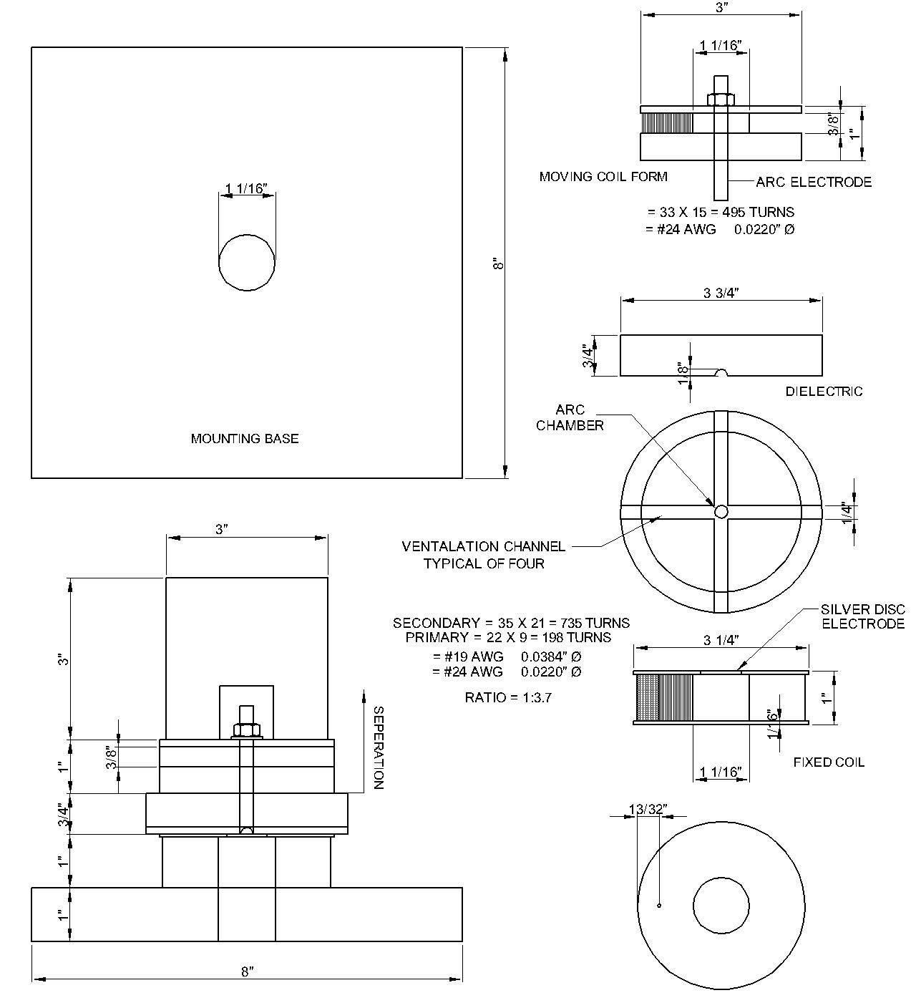
The electromagnets were not simple solenoids but mini bifilar wound Tesla magnifier circuits. They were quarter wave tuned to the delay length of the winding and the lumped inductive-capacitance values of the same. A huge non ringing current pulse was applied to the isolated primary of each electromagnet. The isolated open secondary was allowed to ring. One end (the iron core terminal) was open while the other end of the coil was connected to one terminal of a very low impedance lead-acid battery. This allowed for a generous source of mobile current carriers to be available while also making that end of the transmission line appear to be a dead short. The result was a quarter wave standing wave in each of the electromagnets with the V max collected at the opposing coil electrodes. The opposite electromagnet was wound and wired so that the two opposing standing waves were at opposite voltage polarities and the resulting magnetic fields repealed each other.
The opposing irons cores had to be spaced (about 0.050” apart) so that the standing waves had time to collect and magnify their terminal voltage. Spacing was probably a critical adjustment since being to close would not allow a full standing wave to develop and to far apart would not allow ionization to form.
Once ionization (the spark) developed it took just a few Nano seconds to completely change the dynamics of the standing wave. The addition of the added mirror impedance would now create a half wave delay line from the two quarter wave transmission lines now connected in series. Since they were charged in opposite fashion both of the electromagnets would attempt to completely change their field configuration of the other with a fair amount of stored energy at hand. This conversion process takes place in the iron core (or iron wire) at this time. It is suspected that copper conductors would fail to produce the same effects.
It is believed that some non-classical process briefly transpires during this energy shift and manifests itself as a novel particle that displays a huge repulsion forces (1000X greater than the classical current at in the coils).
It is speculated that the micro physics involved in the new process deals with some property of electron spin. If independent and storable particles are also generated then nothing is known about these entities except the description that Dr. Tesla left behind in his description of “Radiant Energy”.
One step further
Photographic evidence suggests that in 1973 the Gray team was demonstrating that some amount of this anomalous energy could be captured by winding independent collection coils around the electromagnets. It is assumed that this energy could be stored in a capacitor for future use. However the spark between the two electromagnets had to be quenched before the initial excitation energy was completely dissipated. In the popping coil toy this was accomplished during the physical separation of the electromagnets as they shot off into space. The size of these coils was such so that the event was accomplished during the proper “Window of Operation” and probably nobody noticed it for years. In the larger pulse motor, with the weight of its shaft and added flywheel, it was found that the motor had to be already rotating at a minimum velocity in order for the OU effects to take place.
The “Purple” Motor is unique among the first five prototype series. It is the only motor system that employs the use of extra harvest coils around the stator electromagnets. It is assumed that an equal amount of energy was also produced by the rotor electromagnets but there was not enough room and commutator connections available to harvest it at that location. This suggests that this idea of harvesting energy from the opposing coils had been around since 1964.
It appears that this early energy harvest process lead to the 9-pole Free Energy Engine design with its “Floating Flux Field” harvest architecture.

